Cs607 final term current paper (MCQS):

Note:
A video featuring current examination papers of overseas students was available on YouTube; however, the screenshots provided into the video lacked clarity. To address this issue, a digital file has been generated from the original video footage.
Here is the link of that video:
https://youtu.be/_1NVUfY2qyA?si=4C4c3rvFQIkl1wtV

Question: 1
….…… is prerequisite for any mature program of artificial intelligence
Choices:
- Machine learning
- Genetic Algorithm
- Artificial Neural Networks
- Clustering

Question: 2
….…… algorithm finds the maximally specific hypothesis possible within the version space
Choices:
- FIND-S
- Candidate-Elimination
- Genetic
- Artificial Neural Networks

Question: 3

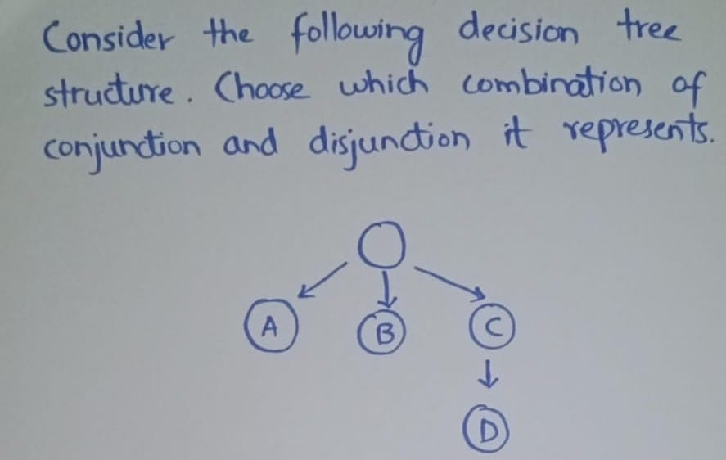
Choices:
- A AND B AND (C OR D)
- A OR B OR (C AND D)
- (A AND B) OR (C AND D)
- (A OR B) AND (C OR D)

Question: 4
In all calculations involving entropy, we define 0 log 0=………….
Choices:
- 0 pg 177
- 1
- Undefined
- infinity

Question: 5
Deductive learning works on ……… facts and knowledge
Choices:
- Fuzzy
- Boolen
- Existing pg 162
- New

Question: 6
In Unsupervised search,a/an ……… represents some specific underlying patterns in the data
Choices:
First two options were not clear
- Target
- Cluster pg 190

Question: 7
In Planning phase each state is represented in ……… logic
Choices:
- Boolen
- Fuzzy
- Predicate pg 197
- Conceptual

Question: 8
….…. is a form of Unsupervised learning
Choices:
- Classification
- Aggregation
- Distribution
- Clustering pg 205

Question: 9
In Linear Model, a linear sequence of steps is applied repeatedly in an ………… fashion to develop the Expert System.
Choices:
- Linear
- Iterative pg 129
- Sequential
- Parallel

Question: 10
In order to debug the program in CLIPS which of the following command is used?
Choices:
- Watch pg 135
- Deffacts
- Deftemplate
- Assert

Question: 11
Getting knowledge from the expert is called …………
Choices:
- knowledge elicitation
- knowledge acquisition
- Inference networks
- Planning

Question: 12
…..…. think like human beings such as ‘tall men’, ‘hot days’, e.t.c. All these groups don’t have a defined boundary but yet humans communicate with each other using these terminologies.
Choices:
- Fuzzy pg 145
- Regular
- Irregular
- Classical

Question: 13
There is a 30% chance that Ayesha belongs to the set of old people, there’s an 70% chance that she doesn’t belong to the set of old people.This is the example of ………
Choices:
- Probability
- Fuzzy
- Classical
- Logical

Question: 14
The truth table values of traditional set theory is……… and that of fuzzy set is ……..
Choices:
- Either 0 or 1, between 0 & 1
- Between 0 & 1, either 0 or 1
- Between 0 & 1, between 0 & 1
- Either 0 or 1, either 0 or 1

Question: 15
Which modifies the performance element that it makes better decisions?
Choices:
- Clustering element
- Learning element
- Performance element
- Observing element

Question: 16
A ……… is a person who possess the skill and knowledge to solve a specific problem in a manner superior to others
Choices:
- Knowledge engineer
- End user
- Option was not clear in the video
- Domain expert pg 122

Question: 17
In Backward chaining terminology, the “hypothesis” to a prove is called the ………
Choices:
- Proof
- Plan
- Scheme
- Goal pg 126

Question: 18
Representation of the hypothesis space H for conjunctions of the attribute T(Temperature) and BP (Blood pressure) can be expressed as ……
Choices:
- H=T , BP
- H=T, T
- H=BP, BP
- H=<T, BP> pg 168

Question: 19
In hypothesis space we have two attributes T(Temperature) and BP (Blood pressure) that can take 5 values each L, N, H, ? and Ø so there are ….. total hypothesis possible
Choices:
- 10
- 15
- 20
- 25 pg 170

Question: 20
In CLIPS …… command is used to delete a fact.
Choices:
- (modify)
- (retract) pg 134
- (assert)
- (single)

Question: 21
As …… system has a stored knowledge base and inference engine
Choices:
- Expert
- Centers
- Web
- MTS

Question: 22
The Candidate-Elimination algorithm represents the ………
Choices:
- Version space pg 173
- Solution space
- Elimination space
- Time space

Question: 23
Boolean logic have ……… values while fuzzy logic have multiple values for evaluation.
Choices:
- Two
- Three
- One
- Multiple

Question: 24
….…… problems usually don’t have well-defined steps.
Choices:
- Structured
- Complex pg 166
- Intractable
- Tractable

Question: 25
The tractable problems are further divided into structured and …… problems
Choices:
- Intractable
- Complex pg 166
- Simple
- Difficult

Question: 26
Inductive learning is based on the knowledge that “if something happens a lot it is likely to be generally ……”
Choices:
- True pg 160
- False
- Uncertain
- Analogous

Question: 27
Artificial Neural Networks is a new learning paradigm takes its roots from ……… inspired approach to learning.
Choices:
- Chemistry
- Physics
- Biology pg 181
- Mathematics

Question: 28
A single layer perceptron can perform pattern classification only on …… problems
Choices:
- linearly separable pg 186
- linearly non-separable
- Intractable
- Non -intractable

Question: 29
In ANNs. MSE stands for ………..
Choices:
- Most squared error
- Mean Squared Error pg 189
- Medium Squared Error
- Mode Squared Error

Question: 30
Which of the following is an advantage of neural networks
Choices:
- Good for generalization
- The power of ANNs lie in their parallel architecture
- Less defined rules to build a neural network for a specific problem
- Knowledge is implicit

Question: 31
A ……… system can avoid any action that is just not possible at a particular state
Choices:
- Planning pg 197
- Fuzzy
- Searching
- Trained

Question: 32
….… deals with procedures that extract useful information from static pictures and sequence of images
Choices:
- Computer vision pg 203
- Neural networks
- Predicate knowledge
- Decision support system

Question: 33
All mentioned are the clustering algorithm(s) EXCEPT …….
Choices:
- Self-organizing maps
- k-means
- Linear vector quantization
- Neural networks pg 205

Question: 34
All mentioned below are the features of robot EXCEPT …...
Choices:
- Reasoning, Dealing with uncertainty
- Vision, Learning
- Autonomy, Physical Intelligence
- Prediction, Classification pg 204

Question: 35
Learning can be described as normally a relatively permanent change that occurs in ……… as a result of experience
Choices:
- Behaviour pg 159
- Conscious
- Unconscious
- System

Question: 36
An expert system may ………… the expert or assist the expert
Choices:
- Cure
- Ignore
- Overload
- Replace pg 113

Question: 37
The entropy is ……, if all the members of entropy (S) belong to the same class (purity)
Choices:
- 0 pg 177
- 1
- 0, 1
- 1, 2

Question: 38
….…… chaining is like an exhaustive search.
Choices:
- Backward
- Parallel
- Serial
- Forward pg 128

